IP Block FAQ:
Q: why would someone get their IP blocked?
A: Because they don’t put in their card number correctly too many times, are using the wrong card, are trying to access a resource they are not allowed to access, etc.
Q: What is a patron being blocked from when their IP address is blocked?
A: An example would be if a person from out of state tries to create an account in Marvel (not using their UMS barcode), their IP will be blocked because people outside the state of Maine are not allowed to use the Marvel system.
A: When there are multiple invalid tries to log into a system resource, the IP address from where those tries are happening will block all access to system resources. At this point, it is not the barcode that is blocked but the computer or network’s IP address.
Q: Would I get, or how would I get the IP address from the patron who is being blocked?
A: yes, you need to get the IP address from the patron. Do not rely on the IP showing in the chat window being the correct one.
A: When a patron gets the blocked message, it looks like this or similar:
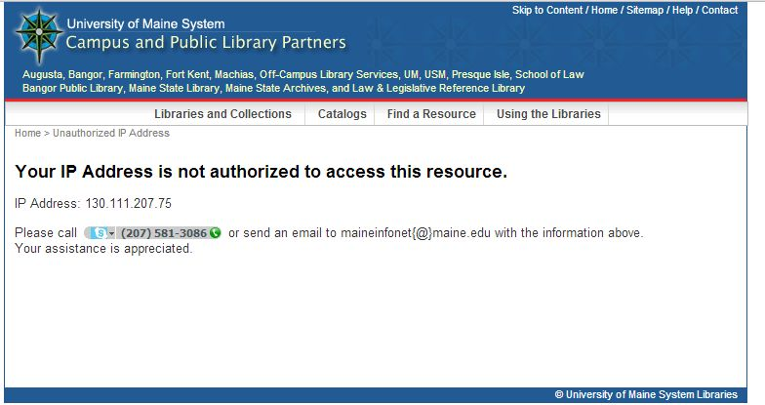
The system will show the patron what IP address was blocked. That is the address the patron needs to send you.

