What assignment looks like after submission:

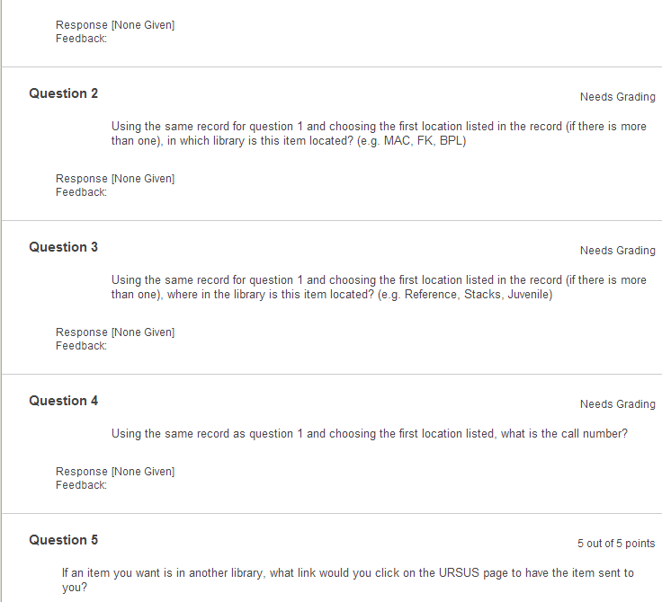

The first page one sees after submitting assignment:

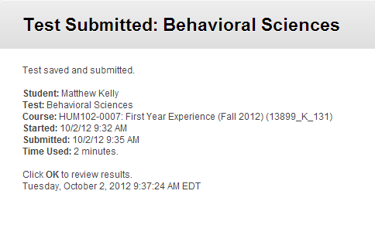

What the grade book looks like:

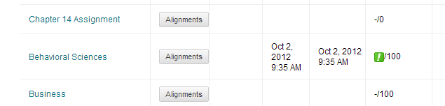

The green box says the assignment has to be graded by instructor.